pfSense

*SOHO Configuration & Remote Desktop*

Adv Cisco Cybersecurity – Lab 5

Jason Liu

Cybersecurity – Mr. Mason & Mr. Hansen

Period 5

*Lab 5: pfSense – SOHO Configuration & Remote Desktop*

**Purpose**

The objective of this lab is to download and set up a pfSense firewall on a LAN device for Small Office Home Office (SOHO) configuration. Then, to access a client behind the firewall using remote desktop from outside the LAN.

**Background Information**

pfSense is a free, firewall software distribution that contains and advertises features that is on par with commercial-grade firewalls. Running on the FreeBSD operating system, similar to UNIX, it uses a custom kernel and additional features can be obtained from third parties. pfSense can be accessed and configured in many ways, the most direct being the interface on interactable mediums like laptops or PCs. pfSense is software only but different hardware can be implemented. We used an external laptop as our device which runs the firewall for this lab.

pfSense software can also be accessed through the cloud – Azure and AWS have pfSense distributions on their marketplace, as well as their GovClouds (US). GovClouds are regions isolated for specific use dedicated to US government agencies, educational institutions, and non-profit organizations. pfSense heavily advertises itself as a widespread, dependable, and an easily implemented firewall with full-feature functions for all. It has a public forum of configuration documents for all users, hosted by Netgate: [docs.netgate.com/pfsense/en/latest/config/?_gl=1*1s75cm*_ga*NjQ5ODg0OTg4LjE2NzAwMTc0OTc.*_ga_TM99KBGXCB*MTY3MDk2MjM4OS4zLjAuMTY3MDk2MjM4OS4wLjAuMA](https://docs.netgate.com/pfsense/en/latest/config/?_gl=1*1s75cm*_ga*NjQ5ODg0OTg4LjE2NzAwMTc0OTc.*_ga_TM99KBGXCB*MTY3MDk2MjM4OS4zLjAuMTY3MDk2MjM4OS4wLjAuMA).

pfSense also has port forwarding control. Common ports are used for major protocols, such as port 443 for HTTPS. In general, port forwarding, also known as NAT, redirects various types of traffic, UDP and TCP ports, and even entire protocols, for servers or applications that require inbound connections from the internet. Remote Desktop is an example of this, as it is an internal application that requires a specific port enabled to extend out of the LAN. Port 3389 is the default port assigned to the Remote Desktop Protocol (RDP), and the port that needs to be enabled for the remote desktop connection. This can be configured on the main dashboard within the GUI.

pfSense is not just a firewall. It also advertises VPN and routing functionality. This involves advanced tunneling, SSL encryption, IPsec, dynamic DNS, DHCP control and many other parallel features seen in Next-Generation firewalls. Being an open-source option in the market with powerful scalability, expansive features, and advanced protection, pfSense is a fierce competitor in the constant race of the cybersecurity world.

**Lab Summary**

Narrowing into our lab, we want to download basic pfSense and integrate it into our network for a basic Small Office Home Office (SOHO) setup, meaning it acts as a middle device between our network and the internet. It should monitor and direct flows of traffic. An example of its implementation and influence can be determined through its port forwarding functions. We attempt to allow remote desktop from an external device outside the LAN, by having it access through the firewall’s allowance of port forwarding.

To summarize, This can be seen as two main parts: the first half involves installing and implementing pfSense, and the second is testing the outbound reach of the firewall using port forwarding.

First, we downloaded the pfSense installation media on an empty USB from their main website. This required the use of Rufus, a portable application service that creates bootable USB drives. Download pfSense on the main site: <https://www.pfsense.org/download/>. After plugging in the bootable USB, now with the pfSense media, the laptop will boot off of the downloaded media and pfSense will be loaded onto the device. Turn on virtualization and ensure that the USB is on the boot priority list in the BiOS. Also note that this is considered an operating image and replaces the previous OS, such as Windows. This is why it is important to run both the USB and the laptop with previous storage and data that are unimportant and are okay to be at risk of disposal. The installation process will now display on the laptop and the procedure process for this lab can be seen in the *Procedure* section. A walkthrough can be found on their community forum located here: [https://docs.netgate.com‌/pfsense/en/latest/‌install/install-walkthrough.html](https://docs.netgate.com/pfsense/en/latest/install/install-walkthrough.html). Install the OS on the largest partition.

At this point, pfSense is running. The laptop should provide two ethernet paths, one to the WAN (the internet), and one to the LAN. Assign the addresses respectively, where the WAN should be assigned to DHCP. The LAN should be a static management IP, so 192.168.1.1/24 was configured. To get to the “webconfigure page” from another PC device, connect to the firewall’s LAN side via a switch or directly. On the webGUI, configure a DHCP server under the services menu. It is only after DHCP server is configured that DHCP may be used from the PC to access the internet. Change the PC IP address back to be obtained automatically to test if basic SOHO is configured and connected to the internet.

Lastly, configure Microsoft Remote Desktop Protocol’s port (MS RDP), port 3389 to have an IP address that can be reached at that port and interface of the firewall. If configured properly, a remote desktop connection from *outside the firewall* may reach inside by pointing at the client’s address and thus the port. Evidence of remote desktop is proof that the firewall is working as a proper intermediary and it’s features are being applied.

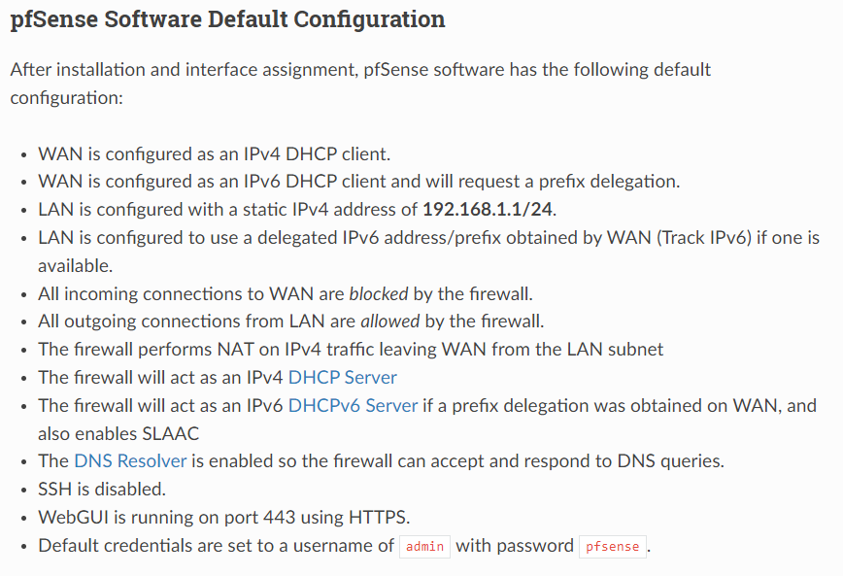Cited image from NetGate’s community installation guide: <https://docs.netgate.com/pfsense/en/latest/install/‌‌‍‌‌‌‌‌install-pfsense.html>.

REFERENCE OF DEFAULT CONFIGURATIONS

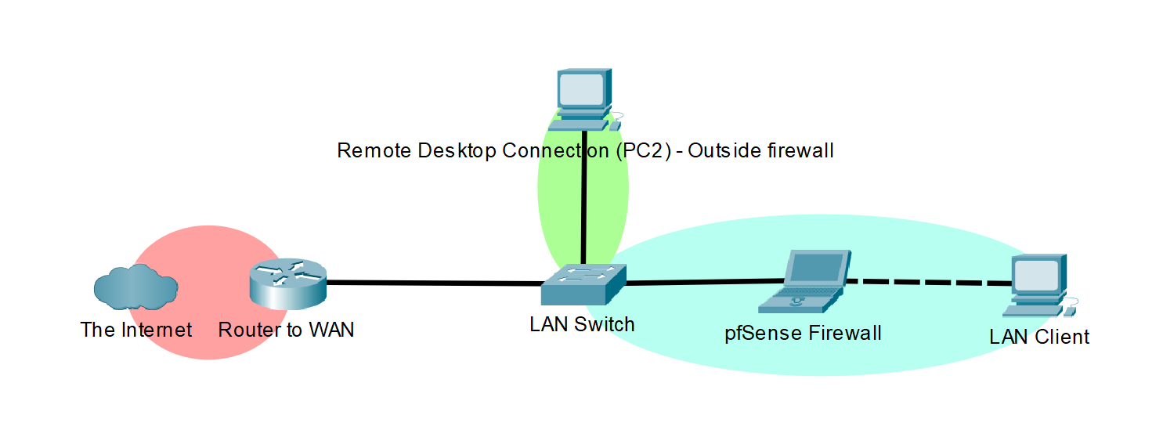

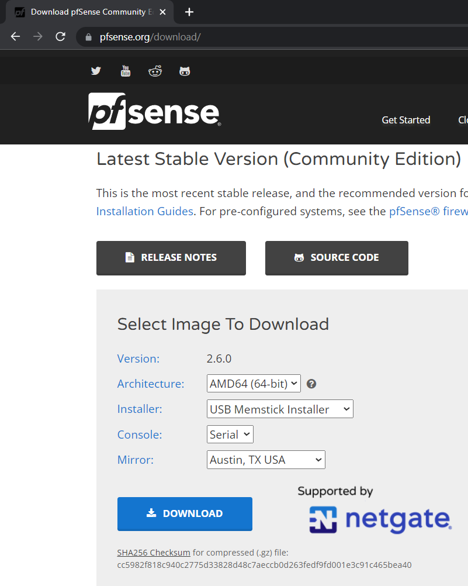**Procedure**

Download pfSense image from the main website. Select the USB installer as we are using a USB as the boot drive.

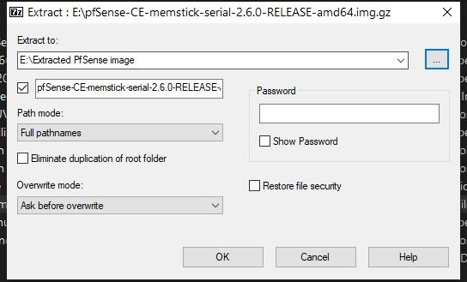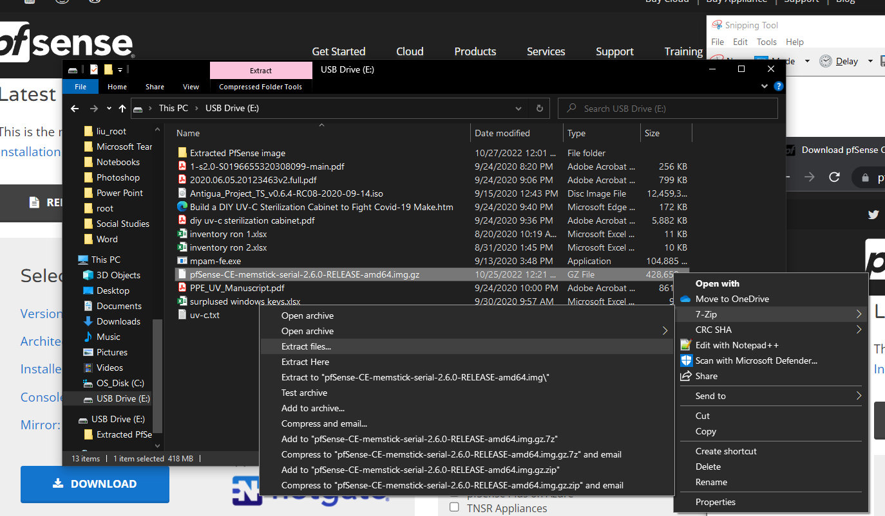

Extract the image using 7-Zip or another extraction application.

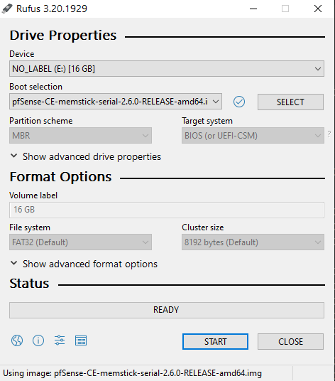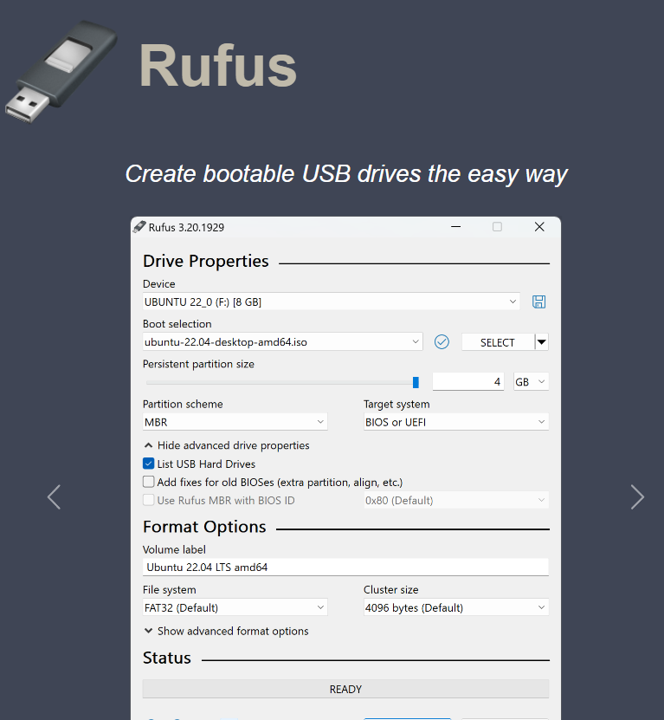

Download and open Rufus from their main website. Select the USB drive to make it the pfSense bootable one.

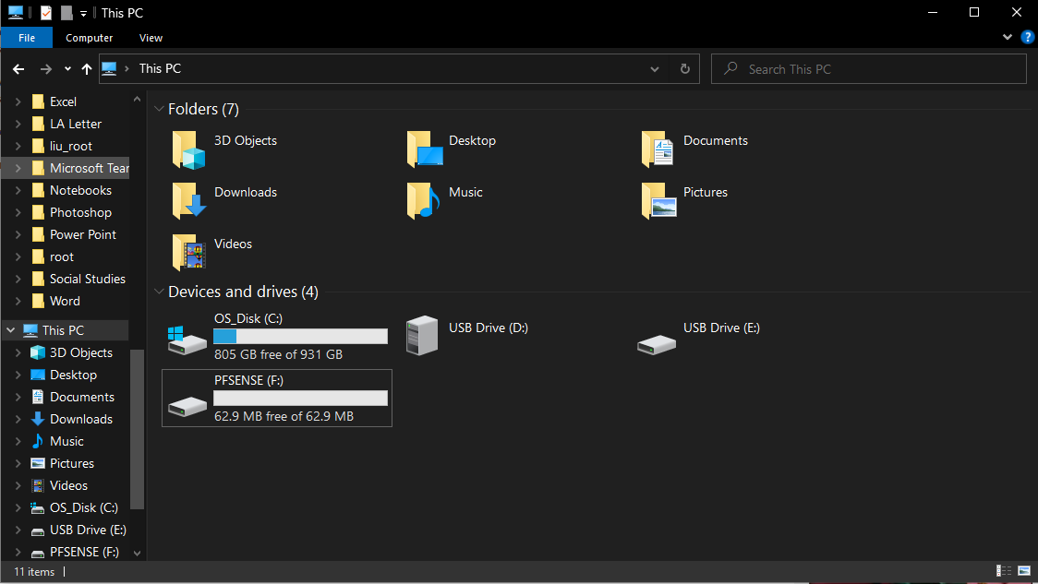

The drive should now appear as “pfSense.”

It is now a bootable drive.

The following images are of the live setup of pfSense on a laptop running as the firewall. It shows the process of going through the pfSense Installer.

First, enter the BiOS.

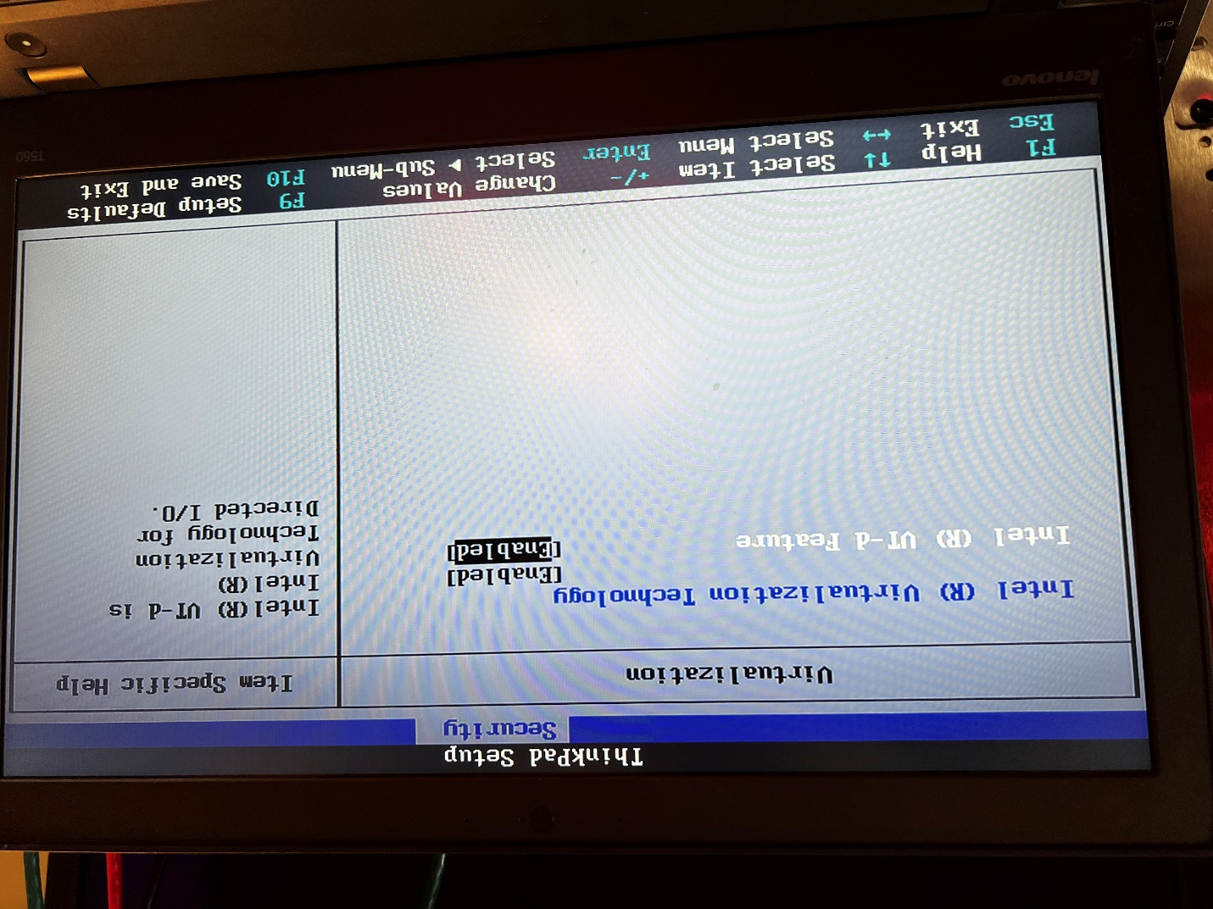

Enable virtualization technology. It is found under the “Security” tab of the BiOS.

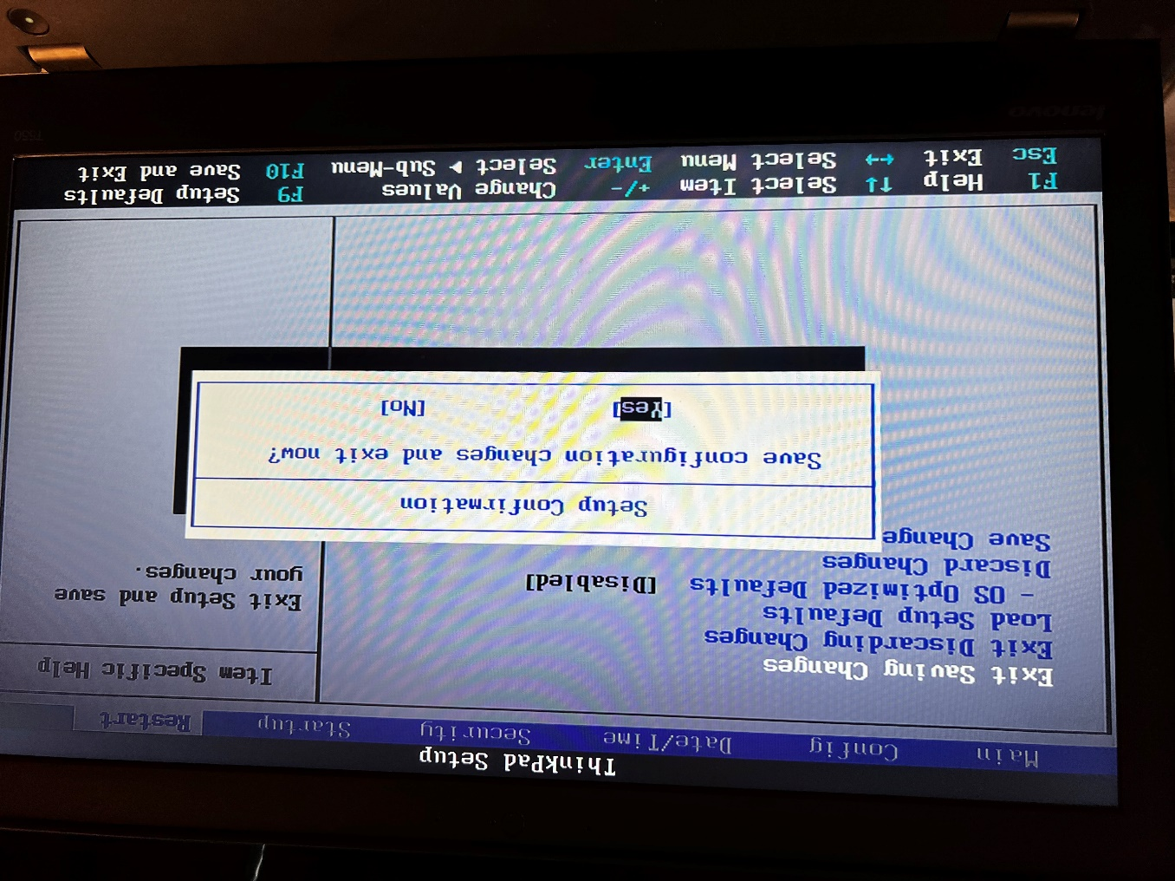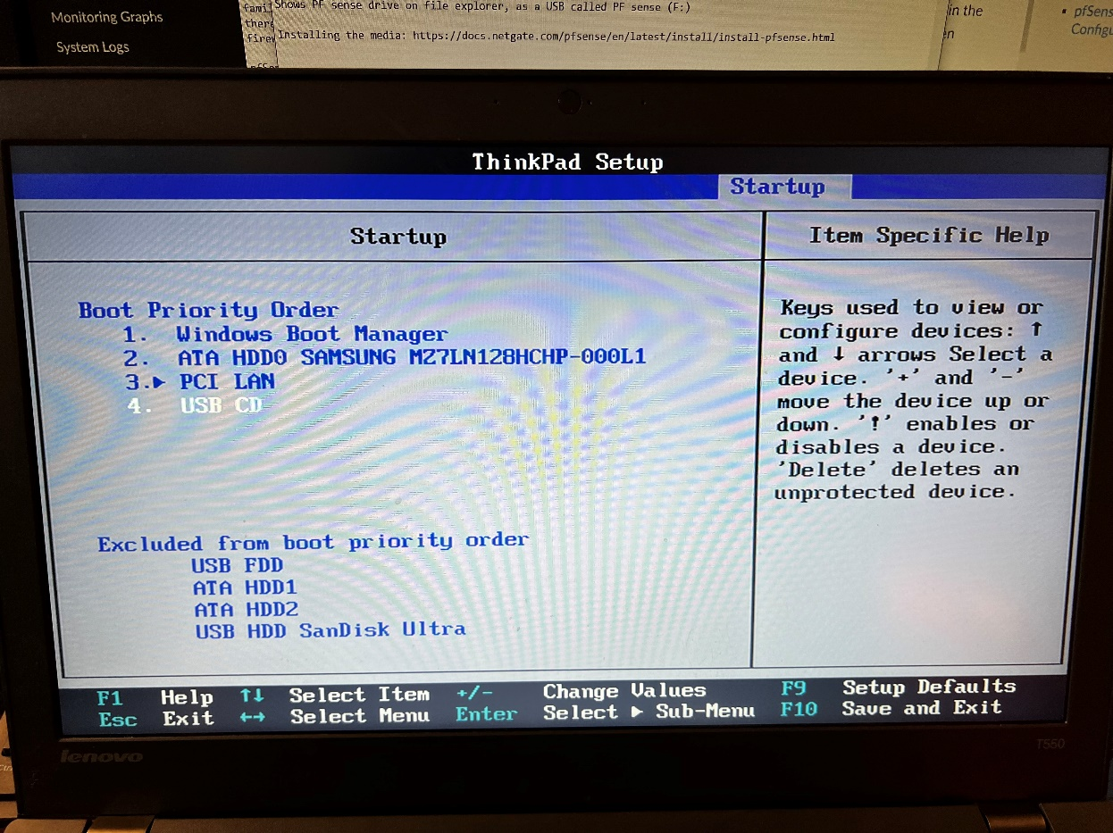

Exit saving changes to exit the BiOS and to reboot the computer.

Add the USB disk to the boot priority list before the Windows Boot Manager. This is found under the “Startup” tab of the BiOS.

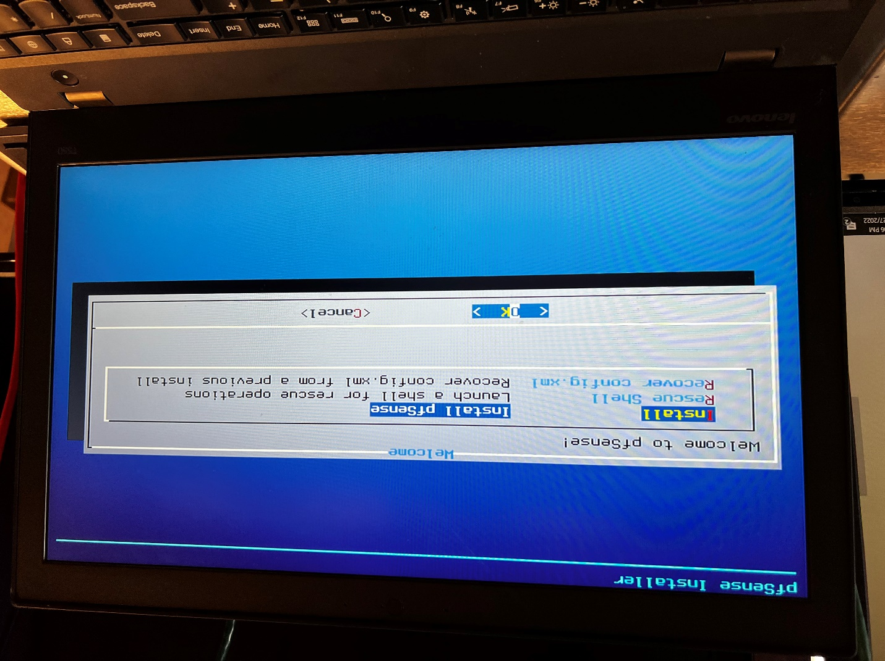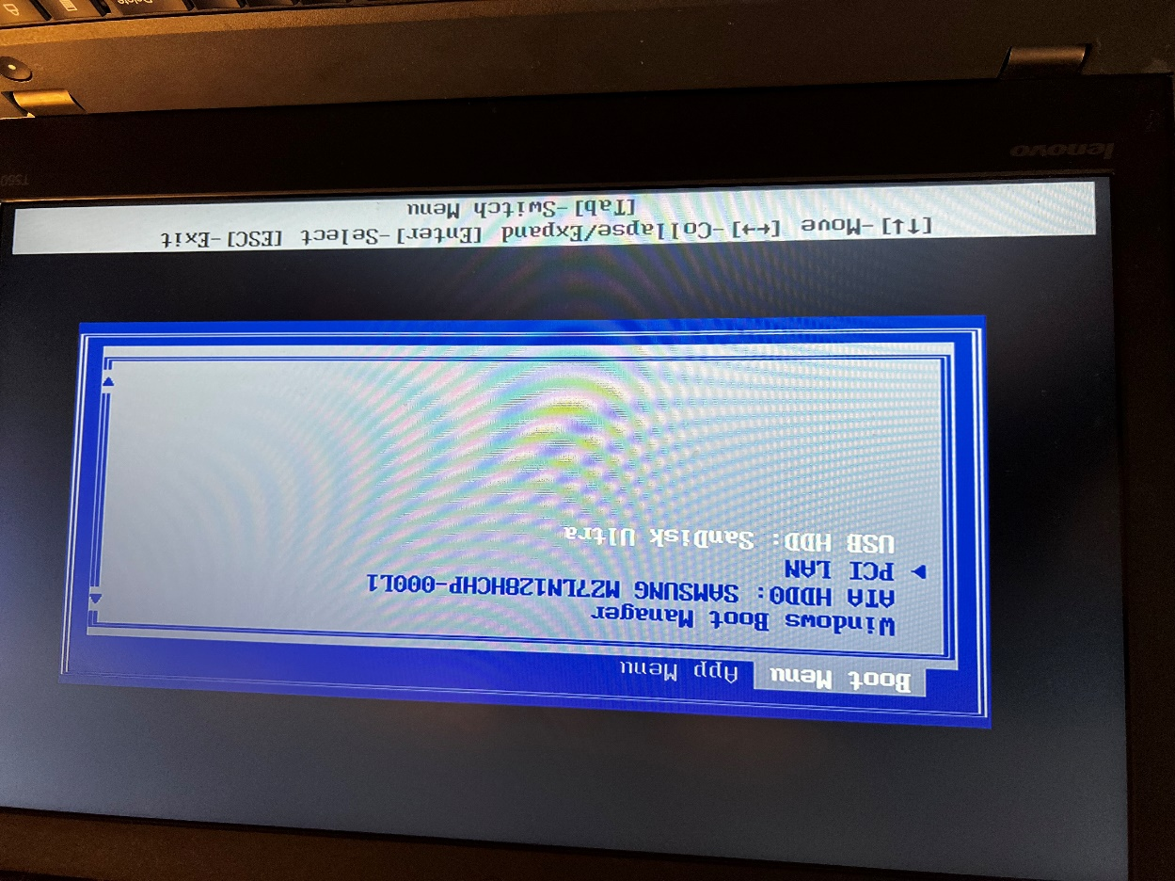

The initial screen of the pfSense Installer. Install pfSense.

The boot menu now gives the option to boot off the USB.

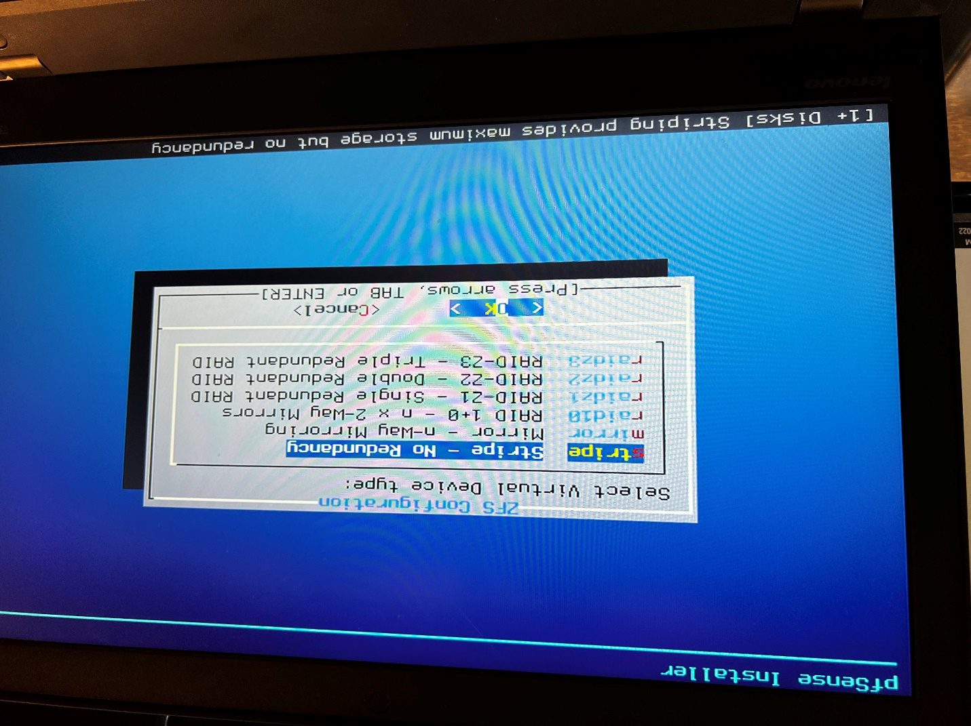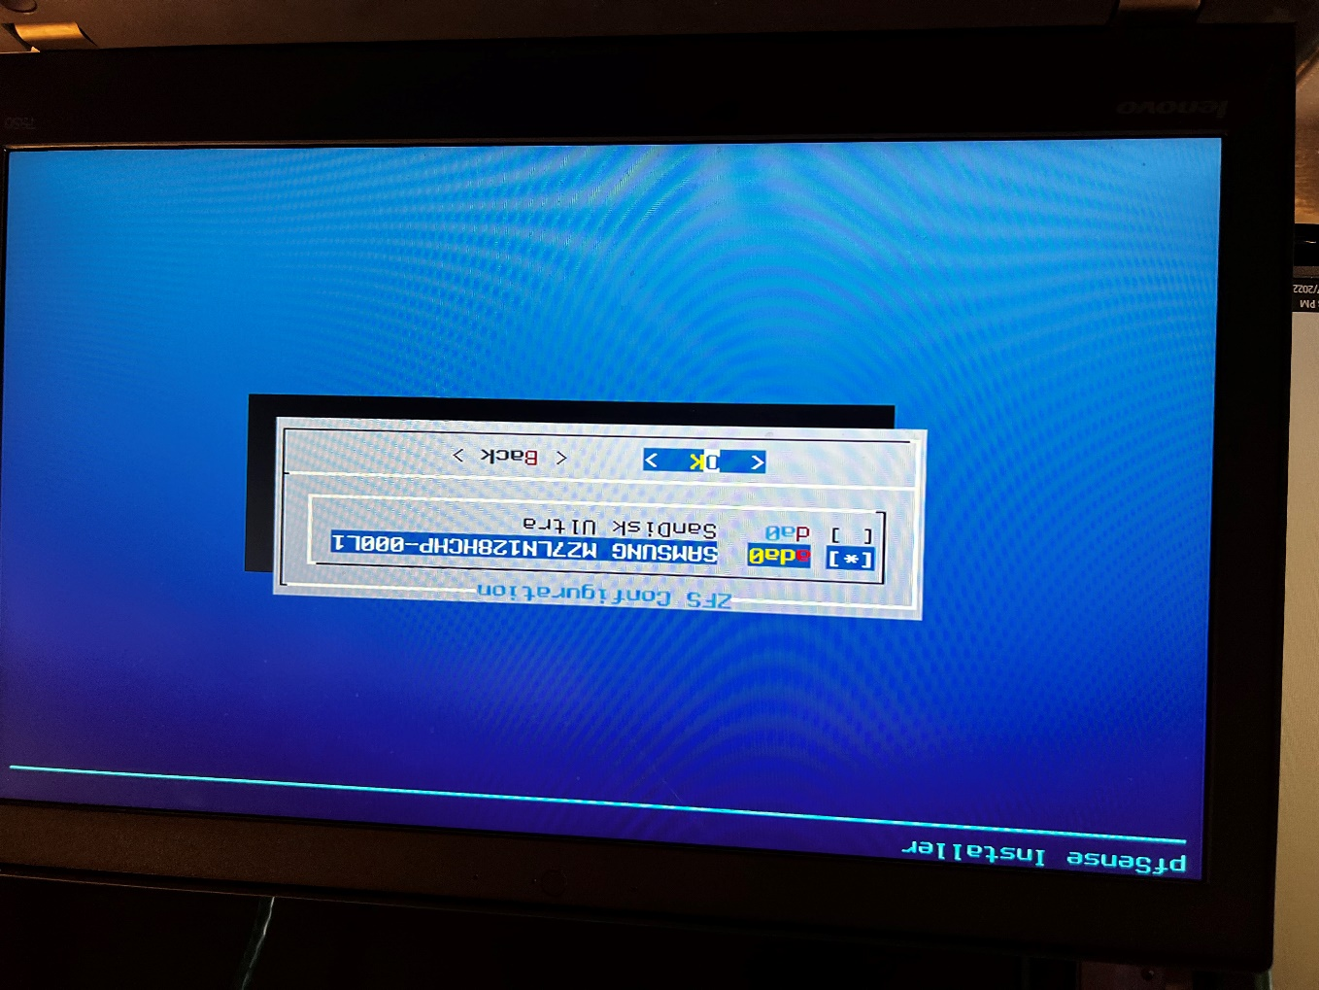

Install everything on the main storage disk, not the USB.

Typically, the default, first choice during setup is the proper one. There is no need for redundancy on the device.

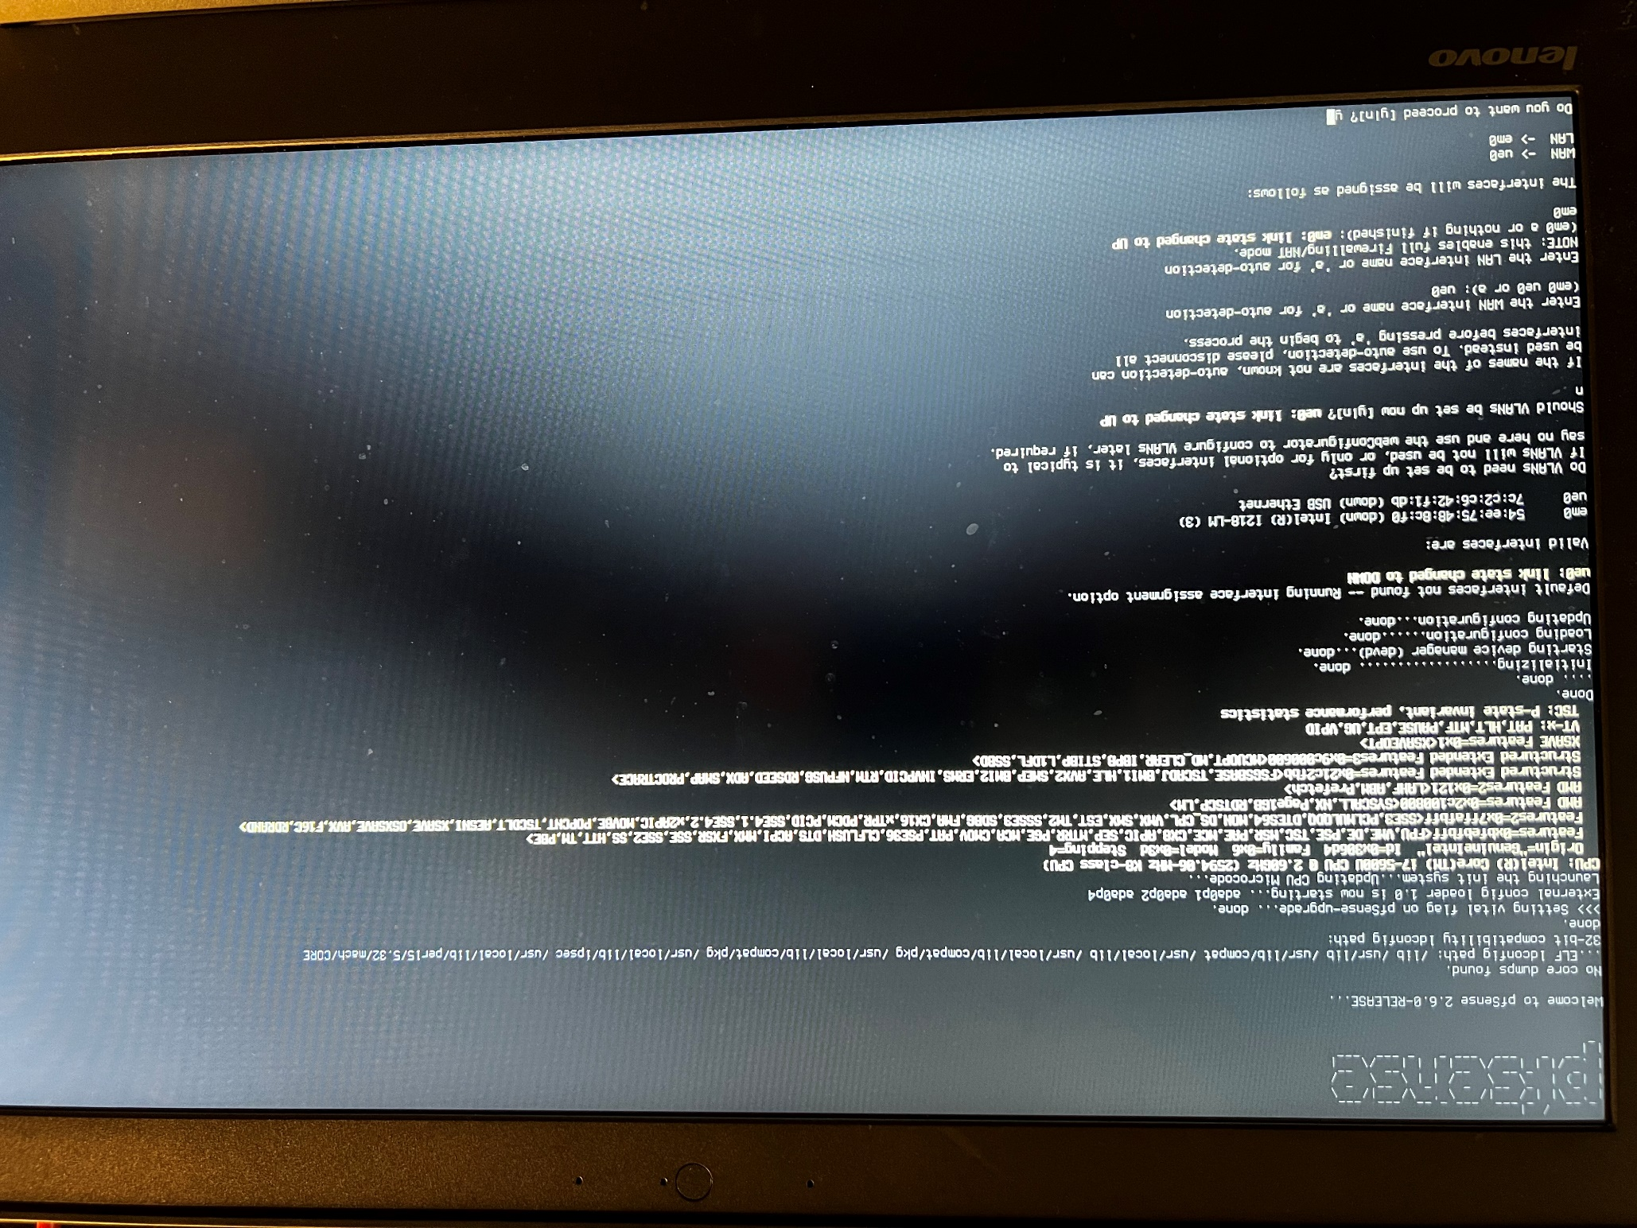

After loading and installing pfSense, the main page should look like this. There is no need to configure VLANs yet. On this page, the interface assignment can be seen. Ensure cabling is done properly at this point. For example, the WAN and LAN have already been assigned to 2 respective interfaces, one via the built-in RJ-45 port and the other via a USB to Ethernet adapter (since there was not 2 built-in ones).

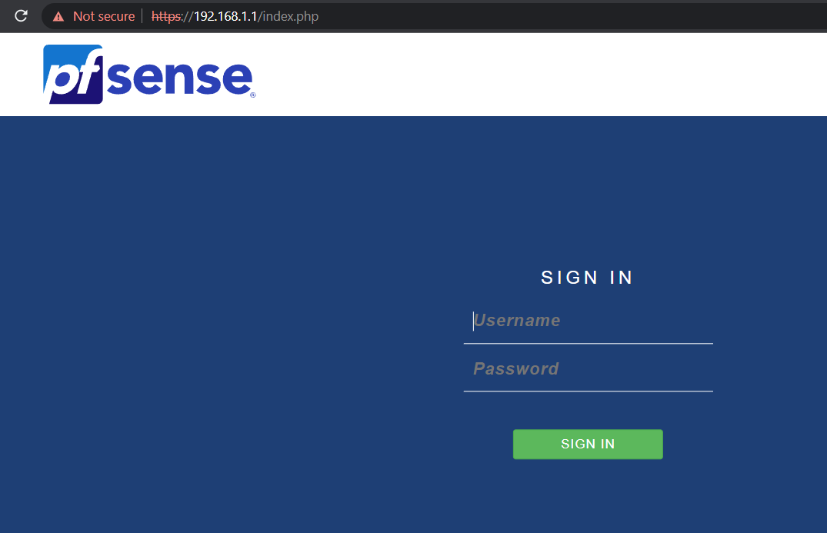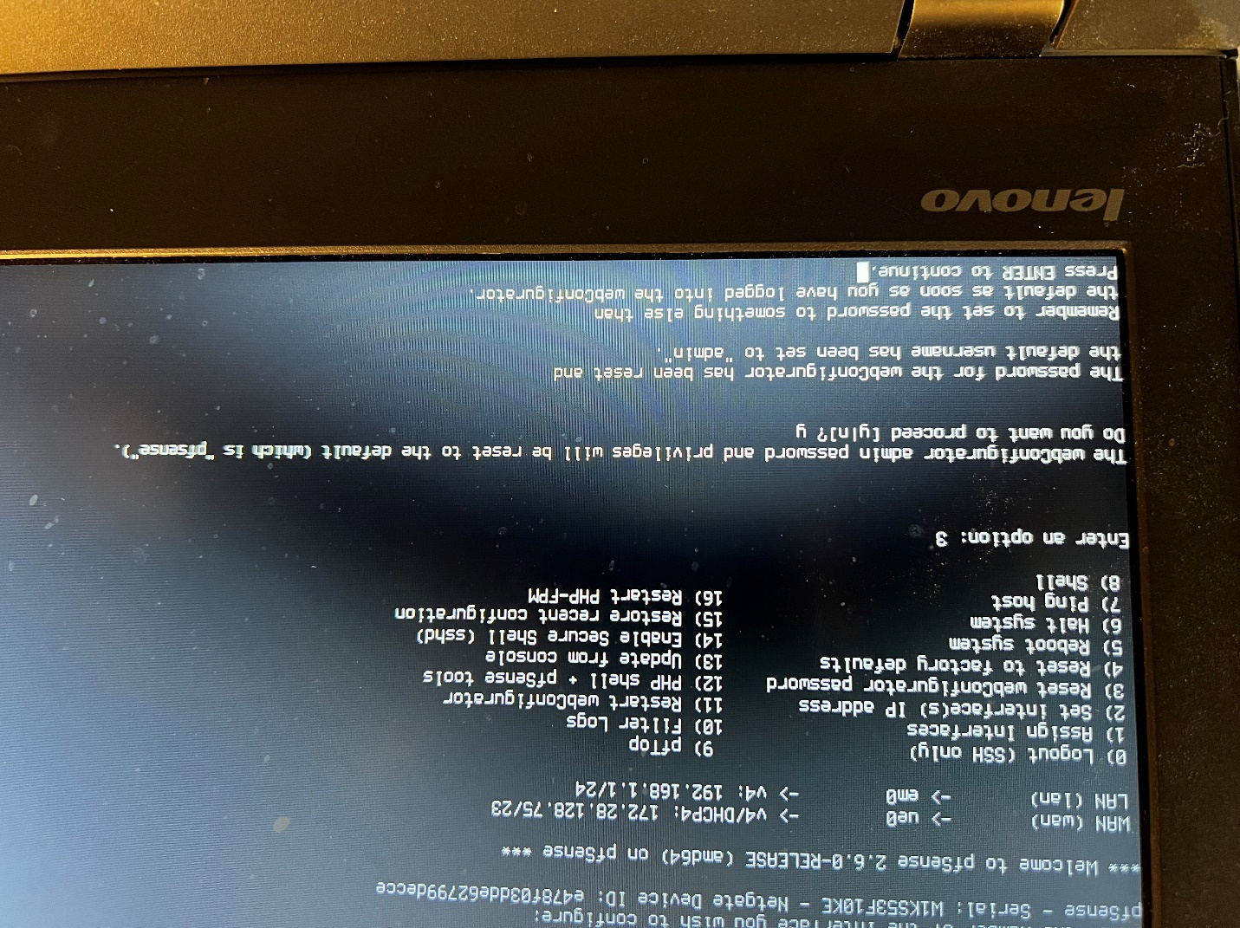

pfSense provides lots of options from this menu. One of them is to create a webConfigurator password and to restart the webConfigurator.

Access the webConfigurator using the default management IP address of 192.168.1.1/24.

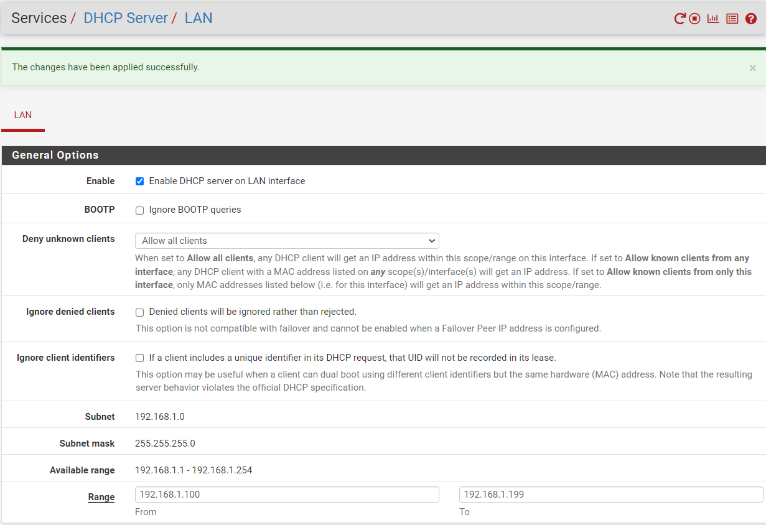

Within the webConfigurator, one important feature to implement is a DHCP server so the LAN client may receive addresses and connect to the internet dynamically. This following configuration was used.

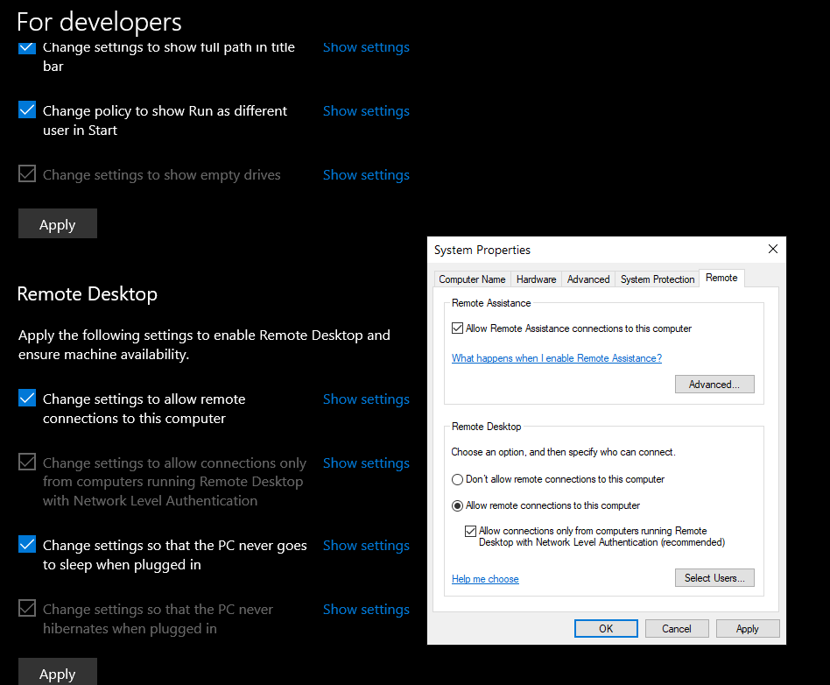The following steps refer to the procedure for remote desktop connection. Also, this video guide was used: <https://www.youtube.com/watch?v=LS96_tC-Tn8&ab_channel=iTalk%28IT%29>

Allow remote desktop on the client computer (behind the firewall).

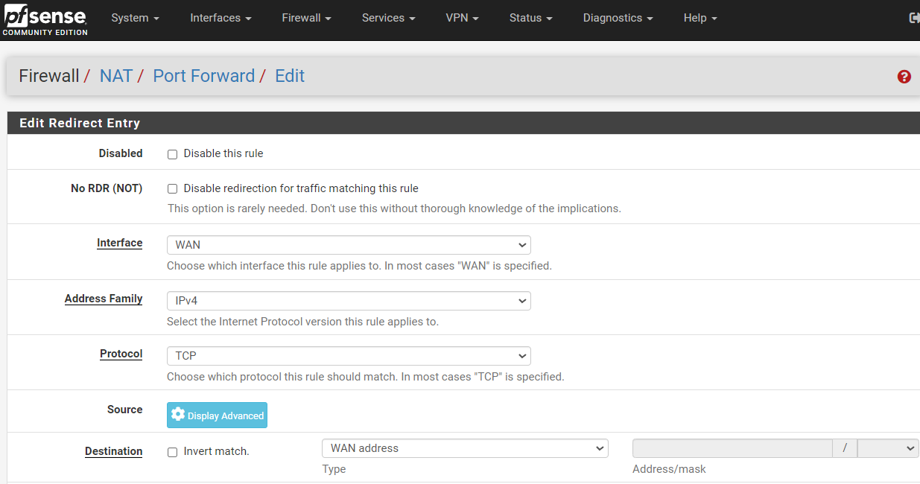

In the webGUI, create a NAT/Port Forwarding policy for RDP.

The below configuration was used.

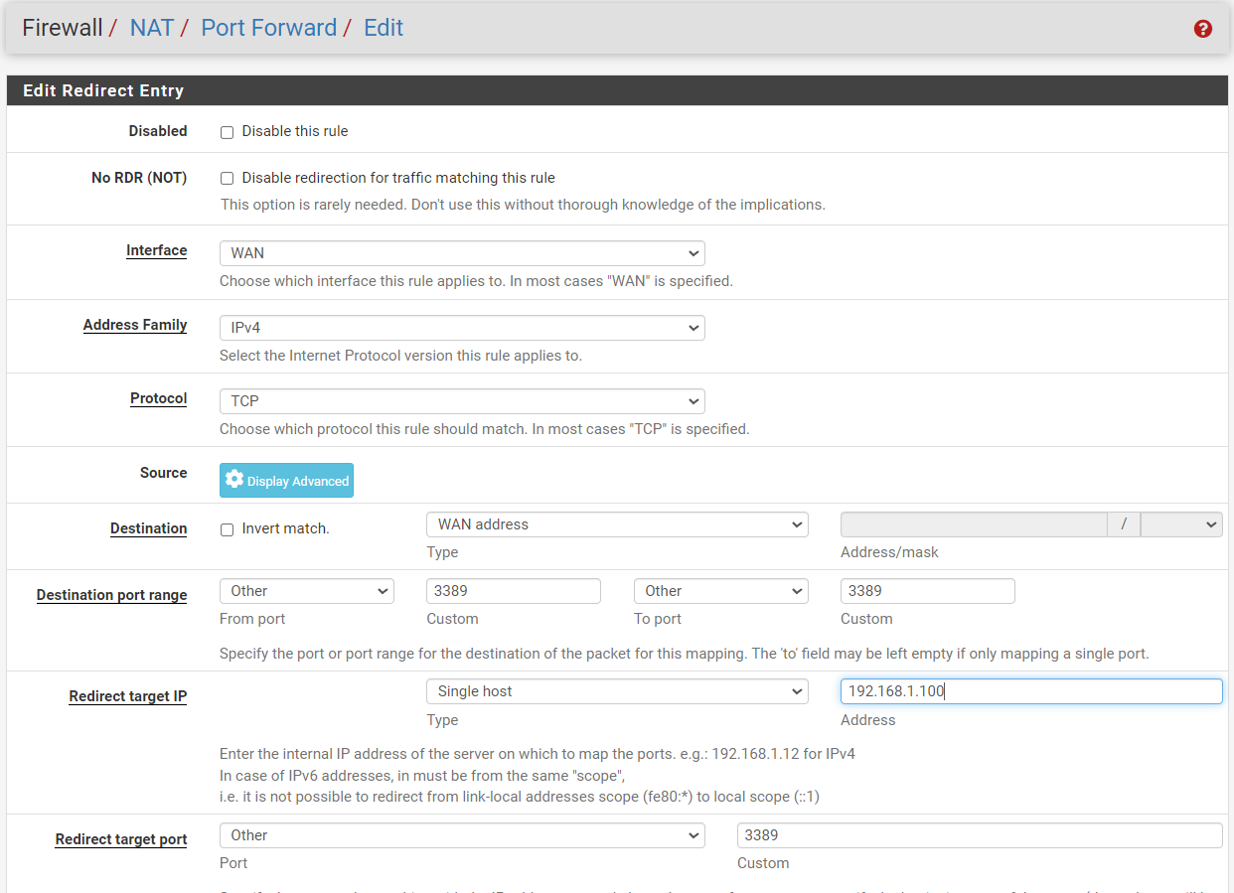

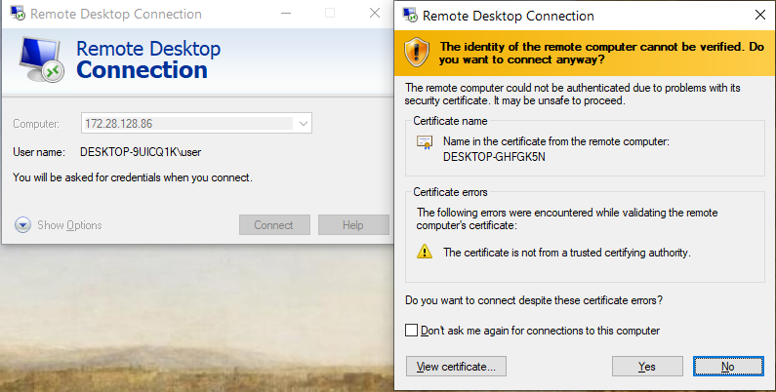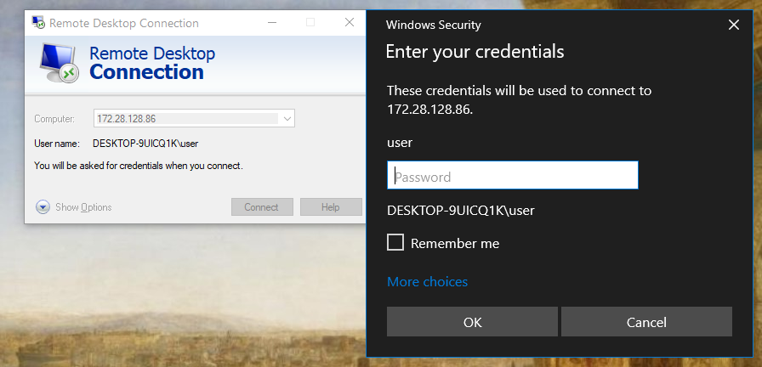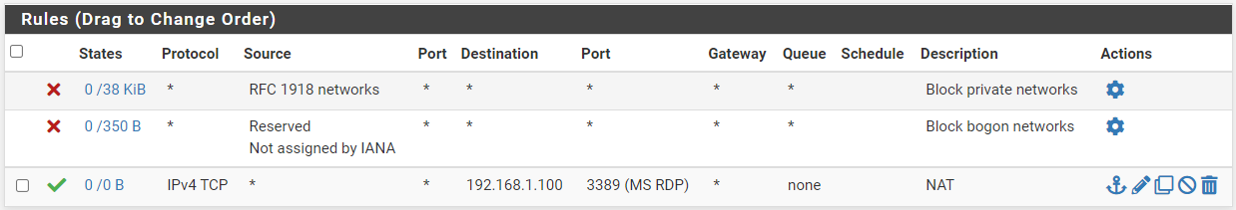

From a SECOND computer, outside the firewall, enter the IP address of the client and enter the password if there is one.

The NAT rule can be seen effective, as well as the MS RDP functioning.

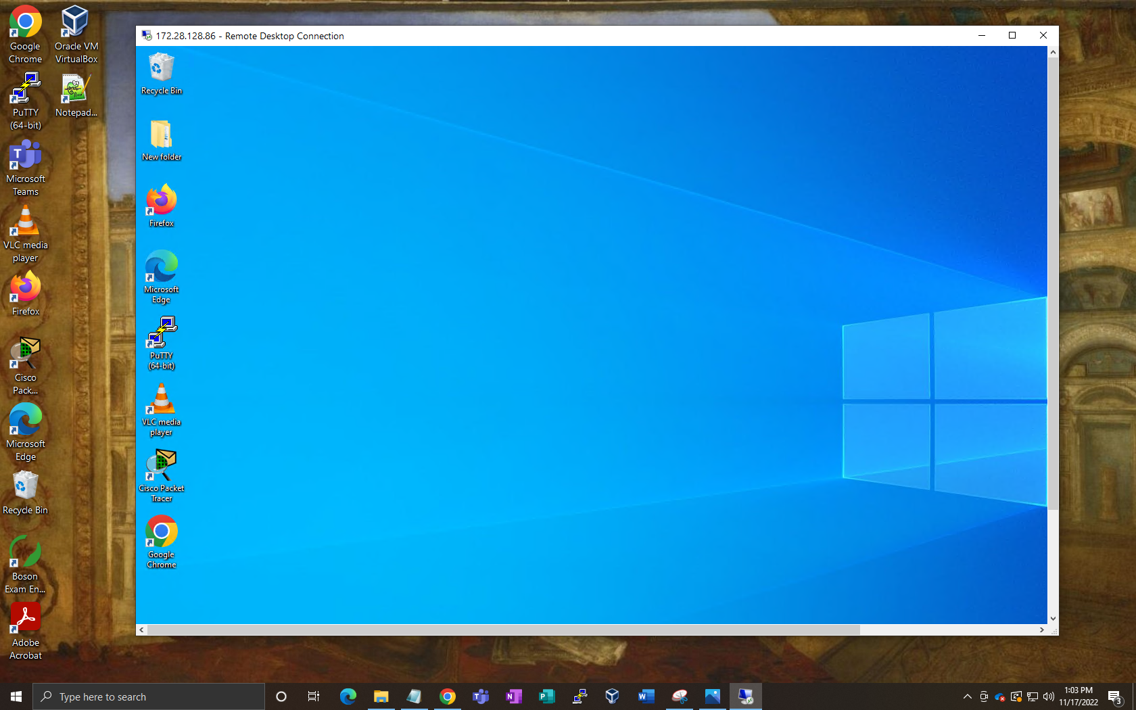

Remote Desktop Connection is configured. All contents of the client PC behind the firewall is reachable from outside it. Port Forwarding worked and thus pfSense is properly running and changes are effective.

**Problems**

pfSense implementation was a multi-step process, and errors between each transition was common.

First, there was a “drive letter error” when trying to select the image Rufus wants to load to the USB. With a quick search, we learned we had to receive the ISO file from the PC computer, not from the drive itself. This is intuitive as the USB should not be replaced by the ISO boot file when the inherent information it receives is already taking place in the USB. Simply said, we downloaded the ISO file elsewhere before reimaging the USB.

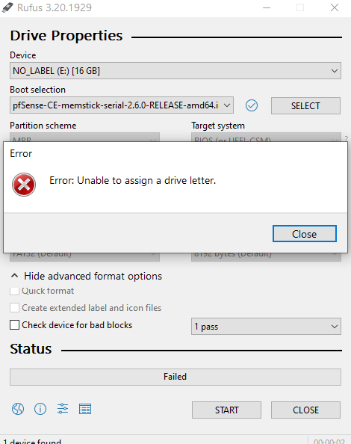

Rufus could not start the reimaging process of the USB. This was due to the fact that the drive could not load the ISO file from inside itself as it is being wiped.

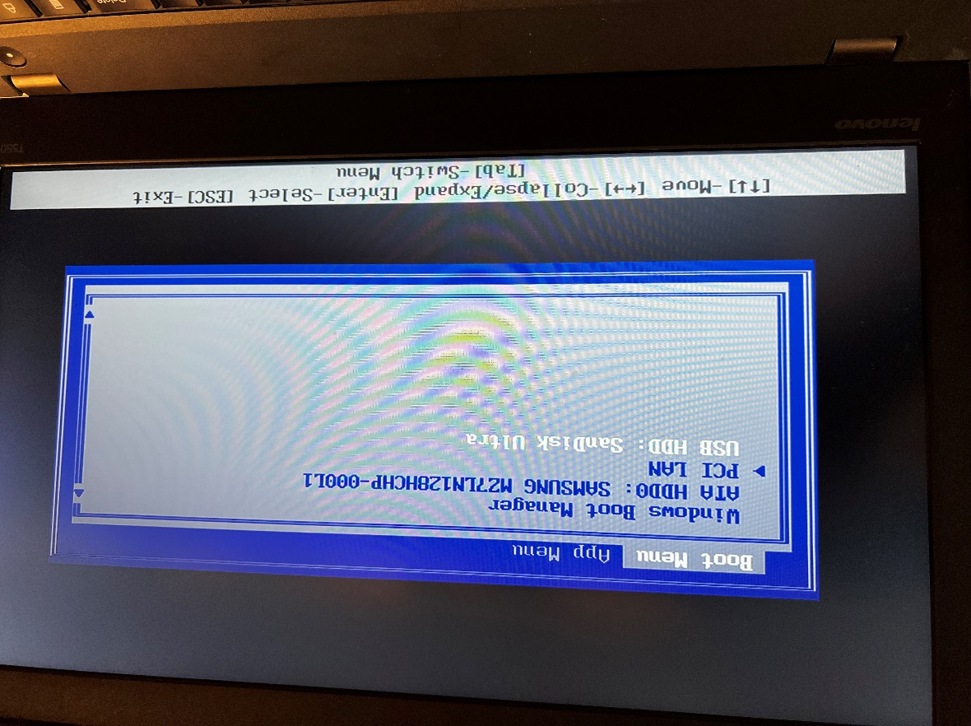 An issue during booting was that the computer didn’t read the USB. It did not load pfSense, but rather continued to load the Windows OS. Upon entering the Advanced Setup Menu (by pressing F12 during startup) and entering the BiOS, we learned that the USB disk was not included in the boot priority in the first place. Putting the USB first in the list and rebooting the computer, the pfSense installation media begins its process smoothly.

Before (left) and after (right) image of adding the bootable USB as an option under the boot priority list.

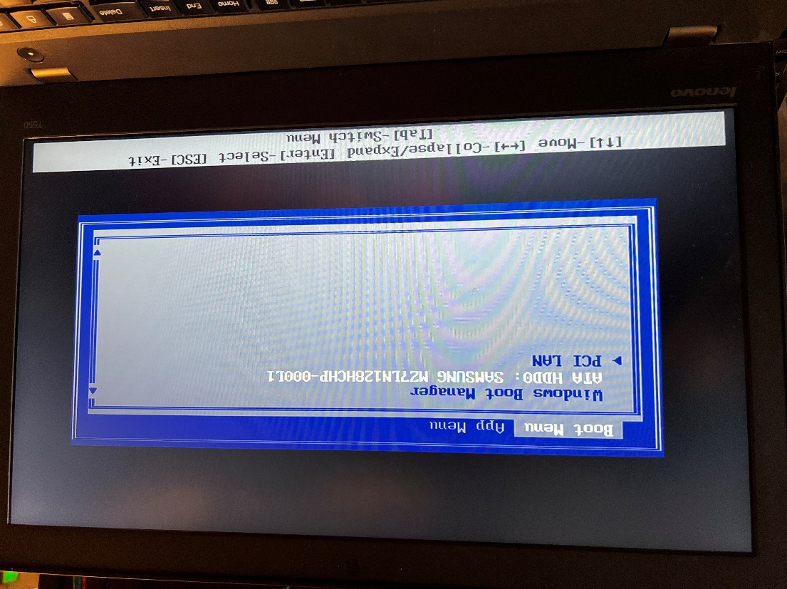

On the remote desktop portion of the lab, there were many issues to mention. First, as we used a rack not part of the main portion of the room, the WAN connection to the internet was set to a different switch entirely. This was a miscommunication that caused us to believe we were connected to the internet when we were not, and instead used WiFi for internet connection by default. This mistake taught us the specific switch and network setup the external rack used.

On the webGUI, we made the mistake of not setting both the *to* and *from* port to 3389, as it is that port that serves as the interface between what is going to and from the computer. Also, if the incorrect port number is entered, such as 3899, nothing would show. Upon entering the correct port number, Microsoft Remote Desktop Protocol (MS RDP) would autofill and show that it is working.

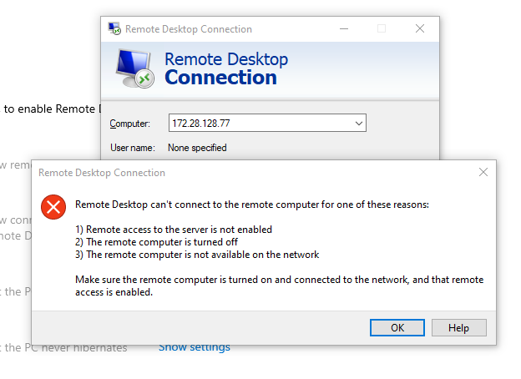 Lastly, our laptop had many issues. Not only was USB not in boot priority list, but there were also inherent software and hardware issues. There were ethernet cables not working. The charging port did not work either. And lastly, the pfSense’s DHCP server and remote desktop connection simply did not work. Upon using a lap peer’s computer, under the *same* configurations and equipment, it functioned. We deduced it was an equipment problem.

Remote Desktop Connections would often not work due to these problems.

**Conclusion**

pfSense as an application is new and complex. However, the interface and download wizard was user friendly and the reference of forums, guides, white paper, and lab peers aided greatly in the successful implementation of pfSense. Otherwise, the wiring and networking aspects were familiar and simple. This allowed a greater focus on pfSense’s unique setup and integration, especially as it is the first time I used Remote Desktop. Further research should be done on specific features and nuances of pfSense’s scope of ability.